Community Engagement Framework (CEF)

Objective

This Community Engagement Framework (CEF) aims to ensure that all project beneficiaries are consulted on, and meaningfully participate in, project design and implementation. Participating communities will play a key role in defining management and mitigation actions which may be needed to address any negative impacts that could arise from project-supported interventions, including changes in access to and use of forest and related resources in Production Forest Areas (PFAs), Protection Forest (PtFAs) or Conservation Forest / Protected Areas (PAs).

The CEF aims to achieve this overarching objective based on the following four core principles:
- All communities will be approached in the spirit of constructive collaboration and made aware of the project’s purpose and potential benefits to participating communities. It will be made clear at the outset that communities have the option to refuse to participate.
- All project beneficiaries, regardless of their ethnic group or social status, shall be engaged in a culturally relevant way on the basis of a Free, Prior, and Informed Consent (FPIC) aimed at establishing broad-based and sustainable community support for the project.
- The community engagement process will take account of ethnic differentiation to ensure that project implementation, including consultations, is inclusive and carried out in the appropriate language(s). Communication throughout the project cycle will use appropriate information, education, and communication (IEC) materials to respond to issues of language and ethnicity, literacy / illiteracy, gender, and social vulnerability.
- All project-affected people will have the opportunity to participate and benefit from the project through participation in the preparation and implementation of Community Action Plans (CAPs) and Community Conservation Agreements (CCAs).

The CEF consolidates a set of social ESF instruments and provides key provisions and procedures to address the World Bank Environmental and Social Framework (ESF) in a single framework. It does this by integrating three important ESF features:
(1) an Indigenous Peoples Planning Framework (or Ethnic Group Planning Framework in Lao context) is provided to ensure that projects are developed with support and input from participating communities;
(2) a process is provided to manage project-related changes in access to or the use of forests and related resources (Access Restriction Framework); and
(3) a Resettlement Policy Framework is provided to manage any (unlikely) instances of involuntary land acquisition for project purposes.

The CEF is based on Free, Prior and Informed Consent (FPIC) with project beneficiaries and affected people, including but not limited to ethnic groups. All participating communities will receive project benefits in a culturally appropriate and gender- and inter-generationally inclusive manner. Where broad community support is not established based on the FPIC, project activities will not be implemented. In summary, the CEF is a voluntary and collaborative process in which participating communities play a key role in the design, implementation, and monitoring of interventions to raise participants’ income and well-being while enhancing the sustainability of forests and related resources.

WB ESF related framework
Nine out of the 10 Environmental and Social Standards require compliance (according to project specifics, some are more others less relevant). The CEF deals with the ESS5 Land Acquisition, Restrictions on Land Use and Involuntary Resettlement and the ESS7 Indigenous Peoples/Sub-Saharan African Historically Underserved Traditional Local Communities. Other ESSs that are relevant to the LLL project are covered in the ESMF.

WB safeguard |  | Environment and Social Framework
Indigenous Peoples, (OP 4.10) |  | Indigenous Peoples (ESS7)
Involuntary Resettlement, (OP 4.12) |  | The Land Acquisition, Restrictions on Land Use and Involuntary Resettlement” (ESS5)

ESS7: “Indigenous Peoples/Sub-Saharan African Historically Underserved Traditional Local Communities”

Indigenous Peoples are inextricably linked to the land on which they live and the natural resources on which they depend. In Lao PDR, In this ESS, the term ‘Indigenous Peoples’ is used in a generic sense to refer exclusively to a distinct social and cultural group possessing the following characteristics in varying degrees:
- Self-identification as members of a distinct indigenous social and cultural group and recognition of this identity by others; and
- Collective attachment to geographically distinct habitats, ancestral territories, or areas of seasonal use or occupation, as well as to the natural resources in these areas; and
- Customary cultural, economic, social, or political institutions that are distinct or separate from those of the mainstream society or culture; and
- A distinct language or dialect, often different from the official language or languages of the country or region in which they reside.

The Lao government use the term ethnic group to refer to Indigenous People. Ethnic groups refer to Mon-Khmer, Hmong Mien, Sino-Tibetan and Tai-upland ethno-linguistic groups, who are socially and culturally distinct from the Lao majority population based on the characteristics described above.

Many LLL Project beneficiaries and villages are expected to be Ethnic Groups and meet eligibility criteria under ESS7. These are considered to be vulnerable ethnic groups in Lao PDR as their livelihood is heavily based on subsistence agriculture and forest. Their land and resources are increasingly under pressure from pro-investment government development policies and commercial natural resource exploitation. Indigenous people lagged behind the majority Lao-Tai at all economic levels. They have more limited access to healthcare, lower rates of education, and less access to clean water and sanitation.

Objective of the ESS7
- To ensure that the development process fosters full respect for the human rights, dignity, aspirations, identity, culture, and natural resource-based livelihoods of IP
- To avoid adverse impacts of projects on IP or when avoidance is not possible, to minimize, mitigate, and/or compensate for such impacts.
- To promote sustainable development benefits and opportunities for IP in a manner that is accessible, culturally appropriate, and inclusive.
- To improve project design and promote local support by establishing and maintaining an ongoing relationship based on meaningful consultation with the IP affected by a project throughout the project’s life cycle.
- To obtain the Free, Prior, and Informed Consent (FPIC) of affected IP in the three circumstances described in this ESS.
- To recognize, respect, and preserve the culture, knowledge, and practices of IP and to provide them with an opportunity to adapt to changing conditions in a manner and in a time frame acceptable to them.

Gender

The project is gender-tagged and plans to mainstream gender issues to ensure differential impacts are addressed. The project will
- commit to increase women and vulnerable people participation by adapting activities including meeting, training, etc., to women schedule and preferences.
- use gender sensitive and participatory approach in order to be inclusive in empowering women in voicing their concerns and in participating actively in decision making.
- Special attention will be devoted to ensure women access to capacity building activities and that women land use rights are recognized.
- enforce NCAW target: women access 50% of VLBG; 45% of budget for training
- subprojects will be designed to incorporate gender consideration during the design, and implementation of the subproject and gender indicators for measuring progress towards gender-related outcomes should be included in the Results Framework and relate to the specific gender-responsive actions taken.

ESS5: Land Acquisition, Restrictions on Land Use and Involuntary Resettlement
The Project’s aim is to develop the sustainable use of forest and other natural resources; no major civil works will be carried out. The project will not involve physical relocation. However, minor land acquisition may be required under community livelihood activities and/or small repair, rehabilitation or new construction of office buildings and other facilities on public land. Any potential land acquisition or land use restrictions will be assessed and managed in a manner consistent with ESS5 requirements. No land acquisition is expected because any civil works will be constructed on un-encroached state land. Detailed designs will be adjusted to avoid such impacts. If, however, circumstances make land acquisition unavoidable, an Abbreviated Resettlement Action Plan (RAP) will be developed.
Objective
- To avoid involuntary resettlement or, when unavoidable, minimize involuntary resettlement by exploring project design alternatives. To avoid forced eviction
- To mitigate unavoidable adverse social and economic impacts from land acquisition or restrictions on land use by: (a) providing timely compensation for loss of assets at replacement cost; (b) assisting displaced persons in their efforts to improve, or at least restore their livelihoods and living standards in real terms, to pre-displacement levels or to levels prevailing prior to the beginning of project implementation, whichever is higher.
- To improve living conditions of poor or vulnerable persons who are physically displaced, through provision of adequate housing, access to services and facilities, and security of tenure.

Applicability

This ESS applies to permanent or temporary physical and economic displacement resulting from the following types of land acquisition or restrictions on land use undertaken or imposed in connection with project implementation:

(a) Land rights or land use rights acquired or restricted through expropriation or other compulsory procedures in accordance with national law;
(b) Land rights or land use rights acquired or restricted through negotiated settlements with property owners or those with legal rights to the land, if failure to reach settlement would have resulted in expropriation or other compulsory procedures;
(c) Restrictions on land use and access to natural resources that cause a community or groups within a community to lose access to resource usage where they have traditional or customary tenure, or recognizable usage rights. This may include situations where legally designated protected areas, forests, biodiversity areas, or buffer zones are established in connection with the project;
(d) Relocation of people without formal, traditional, or recognizable usage rights, who are occupying or utilizing land prior to a project-specific cut-off date;
(e) Displacement of people as a result of project impacts that render their land unusable or inaccessible;
(f) Restriction on access to land or use of other resources including communal property and natural resources such as marine and aquatic resources, timber and non-timber forest products, fresh water, medicinal plants, hunting and gathering grounds, and grazing and cropping areas;
(g) Land rights or claims to land or resources relinquished by individuals or communities without full payment of compensation; and
(h) Land acquisition or land use restrictions occurring prior to the project, but which were undertaken or initiated in anticipation of, or in preparation for, the project.

This ESS does not apply to land use planning or the regulation of natural resources to promote their sustainability on a regional, national, or subnational level. In that case, the project will be required to conduct a social, legal, and institutional assessment under ESS1, in order to identify potential economic and social risks and impacts of the planning or regulation, and appropriate measures to minimize and mitigate them, in particular those that affect poor and vulnerable groups.

Community Action Plan (CAP) and Community Conservation Agreement (CCA)

The LLL project falls into the category of projects with minor land acquisition or restrictions on land use. It is unlikely that the activities supported by the project will have significant or irreversible impact as it will unlikely result in any loss of private land or assets. Furthermore, physical relocation of households or businesses is not allowed. Although minor impacts are expected the impact will be minimized, mitigated and compensated with management incorporated at the management stage.

The LLL Project will support a stricter enforcement of PFAs, PtFAs and PAs management which will restrict the current access of local people to forest areas and natural resources.

The CEF sets out provisions and procedures to ensure that any negative impact on livelihoods, caused by land acquisition or restrictions in access to resources, will be avoided, or minimized and compensated by means of sustainable solutions as set out in participatory Community Action Plans (CAP) and Community Conservation Agreements (CCAs).

CAP: Inside PFA and PtFAs, in cases where project activities may result in restrictions of access to natural resources, Community Action Plan (CAP) will be developed. The CAP serves as an Ethnic Group Development Plan (or Indigenous People Plan) as well as one of the main instruments to address and manage risks and impacts of restriction of access to land, natural resource and forest resources resulted from the project implementation.

CCA: In the Protected Areas (PAs) a Community Conservation Agreement (CCA) that will serve as Process Framework (PF) and will be developed for each guardian village. The Community Conservation Agreements seek to protect the integrity of the Protected forest by providing sustainable improved livelihood options for communities, in return for verified conservation action, strengthening and building the capacities of local communities on sustainable forest management and governance as well as raising awareness on the importance of biodiversity conservation.

The CCA process involves documentation of traditional practices of communities that reinforce conservation, including the location of sacred sites, burial grounds, spiritual sites and other areas which are designated by the IP community for conservation purposes and sustainable use. In the PAs, Nature-Based Tourism Investment Agreements (NBTIA) will be realized between PA Authorities, Community, and private service providers.

- Both the CAP and the CCA will be prepared through an inclusive and consultative process incorporating concerns, needs and priorities identified by ethnic groups.
- Both the CAPs and the CCAs will be designed with local communities and will be tailored to specific situations and needs and incentives for community compliance are provided through Village Livelihood Block Grants (VLBGs) to develop alternative livelihoods to reduce dependency on forest resources for livelihood. Village Land Use Planning (VLUP) will be conducted in each village prior to the CAP and the CCA.
- Both CAP and CCA will clearly assess and provide measures to enhance positive project benefits and avoid or mitigate potential adverse effects and will serve as a local action plan to address any changes or restrictions in resource access.
- Forms required for approval of community grants will be included in site-specific CAPs/CCAs. The community through the FPIC process will endorse CAPs/CCAs.

Vulnerability, Gender, and Ethnicity

Where possible, local communities and Indigenous Peoples should be allowed to exercise preexisting access or usage rights to Borrower-controlled land. For example, forest dependent may claim legal or customary rights to access or pass through project-controlled land periodically or seasonally, for subsistence and traditional activities. Their claims may be linked to certain natural resources such as an oasis or water spring, herds of migratory animals, or plants that grow naturally, that can be harvested only at a particular time of the year, or are pollinators for other plants, trees, or crops.

The LLL Project recognizes that certain social groups may be less able to restore their living conditions, livelihoods and income levels and has incorporated these concerns into the preparation and implementation of project activities through an adoption of participatory planning and decision-making process. 20% of the village Development Fund will be devoted to the most vulnerable people of each community.

The ESF Team consisting of and ESF Focal Staff and Consultants based in PCU in Vientiane Capital. The ESF Team will provide training on the CEF process for the Project Assistants based in the District (DAFO) and will closely monitor the application of the CEF during the preparation of proposals and the implementation of the projects in all areas.

Implementation arrangement
Project support at village level would be delivered as a ‘package’ of support, according to the type of forest category the villages are located in. Village facilitators (young graduates/junior consultants, each covering 3-4 villages) would support DAFO and PAFO staff in daily village engagement, mobilize communities, follow up on technical and extension support and monitor and report village level activities to the District project team. In general, the process of land use and resource planning and use, technical extension and small-scale infrastructure would be complemented a Village Livelihood Development Grant (VLDG) (block grant) managed by the Village Fund as a revolving mechanism for household forest-smart livelihoods activities
Engagement at village level by forest category
Forest type | Protection Areas | Production Forest Areas | Protected Forest Areas
Forest type | PA | PFA | PtFA
Management  arrangements | Collaborative Management | PSFM/Village Forest Management | PSFM/Village Forest Management
Management  arrangements | CM | VFM | VFM
Actors | Protected Areas organization  District Technical Team | DAFO/PAFO | DAFO/PAFO
Step | VLUP | VLUP | VLUP
Activities | Forest patrolling,  Biodiversity monitoring,  NTFP management,  Training | Family and community use  of timber and fuelwood; (ii) timber  harvesting, storage, processing,  and marketing;  (iii) NTFP harvesting, storage,  processing, and marketing. | Family and community use  of timber and fuelwood; (ii) timber  harvesting, storage, processing,  and marketing;  (iii) NTFP harvesting, storage,  processing, and marketing.
Labor  opportunities /  training | Vocational training: tourism,  casual labor in the  construction of  tourism-related small  scale infrastructure  such as trails,  campgrounds,  small facilities | Training Sustainable Forestry Management,  Participatory annual forest management, Quarterly NTFPs  Job opportunities:  through dedicated vocational  training for farm and off-farm jobs. Opportunities for casual  labor in village small  scale infrastructure construction  Partnerships with industrial  tree plantations /  establishment of smallholder  tree plantations  based on location and demand | Training Sustainable Forestry Management,  Participatory annual forest management,  Quarterly NTFPs  Job opportunities:  through dedicated vocational  training for farm and off-farm jobs.  Opportunities for casual  labor in village small  scale infrastructure construction  Partnerships with industrial  tree plantations /  establishment of smallholder  tree plantations  based on location and demand
VLDG | Village Livelihood Grant  20% to poor HH | Village Livelihood Block Grant  20% to poor HH | Village Livelihood Block Grant  20% to poor HH
Funding | PCU to PA | Management activities: National PCU to the provincial PCU  VLDGs: National PCU account to the VDF | Management activities: National PCU to the provincial PCU  VLDGs: National PCU account to the VDF

Detail of engagement process

Free Prior and Informed Consent (FPIC)
The development of an effective procedure for consultation in accordance with international standards is certainly one of the greatest challenges facing by the LLL Project. The process of obtaining FPIC is the most important tool for community engagement.
FPIC is generally understood as the right local communities to approve or reject proposed actions or projects that may affect them or their lands, territories or resources. “Free, prior and informed consent” should occurs freely and voluntarily, without any external manipulation, interference, or coercion, for which the parties consulted have prior access to information on the intent and scope of the proposed project in a culturally appropriate manner, form, and language.
FPIC is a right of indigenous and local communities, supported by many international laws, instruments, and conventions, most notably the United Nations Declaration on the Rights of Indigenous Peoples (UNDRIP).
To define FPIC it is useful to reflect on what FPIC is not: FPIC is not community consultations, community dialogue, community engagement, community facilitation or negotiations. These are concepts and tools for which FPIC can be achieved. FPIC is built upon these tools and concepts, but moves beyond them in redefining power in relation to decision making. FPIC is not an approach, but a set of steps that empowers indigenous or local communities to give their consent, in terms of a “yes” or “no” at different stages to an external proposal.
Free should imply no coercion, intimidation or manipulation;
Prior should imply consent has been sought sufficiently in advance of any authorization or commencement of activities and respect of time requirements of indigenous consultation/consensus processes;
Informed means that consultation must be based on adequate and relevant disclosure of project information, and using methods of communication that are inclusive (i.e. include various levels of vulnerability), culturally appropriate, and adapted to community language needs and decision-making and cover (at least) the following aspects: nature, size, aspects; purpose; areas; foreseen impacts; human resources; procedures; opportunities, timeframe, etc.).

Consent
Consultation and participation are crucial components of a consent process. Consultation should be undertaken in good faith.
A decision on consent is an important part of the village consultation process, it represents villages’ willingness to participate in the project. To reach a genuine decision on consent, participation must be done that is based on open and honest consultations. Village consultation process should include as many representative villagers as possible. Some key aspects related to consent include:
- It must be made clear at the outset that communities have the option to refuse to participate in parts of the project which they are not legally obliged to;
- All issues which require village consent must be known to people at the start of the VCP
- How consent is given is agreed to by all people attending meetings;
- Consent at any time of the consultation must be made only when forest dependent communities having reasonably understood the project;
- Peoples should be able to participate through their own chosen representatives customary or formal;
- Regardless of the selected consent process the project team must include a gender perspective (the participation of women is essential, as well as youth and elders, poor and marginalized). The team must make a strong effort to mobilize women to attend the consultation meetings.
FPIC process must be conducted and consent reached for each of the project main stages or incentive for conservation and sustainable forestry management.
- Village Land Use Planning (VLUP)
- Community Action Plans (CAP), which serves as Ethnic Group Development Plan (EGDP) under this project (or IPP in ESS7).
- Community Conservation Agreements (CCA) which serves as Process Framework
- Nature-Based Tourism Investment Agreements (NBTIA) (between PA Authorities, Community, and private service providers)
- Agreement with private companies involved in commercial tree plantation
- Inter-village agreements related to physical investments (irrigation schemes, etc.)

Who can provide consent?
Based upon the experience gained during the SUFORD project and taking into account the number of target villages, the human resources capacity and the time available, that the most suitable process to obtain community consent is to involve as many villagers as possible (and with minimum participation requirement as prescribed below) in each eligible community and hold a majority vote.

FPIC process documentation
Documentation of the FPIC process is important for a number of reasons. Recorded evidence of decision making and recorded evidence of grievances help protect the interests of communities and project proponents. Documentation is also useful for learning and sharing and reporting back to communities, project owners, other projects and external verifiers. The FPIC process will be verified during a social assessment externally conducted on a yearly basis

Good Practice Principles for FPIC
- It is essential to develop a good understanding of the local culture, including factors such as social organization and consultation systems, before engaging in FPIC.
- Information provided should be as independent, comprehensive, and accessible as possible: this may imply translation into local languages and use of audio-visual materials.
- Agreements should be written and notarized, in addition to the traditional form of recognition, and there should be video or photographic record of the process.
- Free prior and informed consent be understood as a process by which local communities, government, and companies may come to mutual agreements in a forum that gives affected communities enough leverage to negotiate conditions under which they may proceed and an outcome leaving the community clearly better off.
- Methodologies used in the consultation process need to be informed by knowledge of village social organization. In this respect the consultation process might be described as a system for finding a system that is sensitive to the cultural setting.
- Consultation is also a feedback loop. Information that emerges from the process in continually fed back into the process always evolving and adapting to a changing situation as villagers become more competent and confident in their abilities and capacity.
- The structure of the consultation process must be flexible so that it can be carried out in culturally appropriate ways.

Community Engagement Process Stages

Community consent will be obtained during main project stages to ensure that the community is fully aware in project implementation, fully involved in decision making and validate each stage. It is hard to measure broad community support and it is also difficult to decide who the legitimate representatives of a community are.
In some of the key project stages the deliverable will consist in community agreement. The purpose of a community agreement is to formalize the community support to the project. The process of agreement making is as important as the outcome, and a properly constituted agreement process is evidence that new projects conform to FPIC. The process for reaching a community agreement needs to be well planned, resourced, executed and documented.

The Community Engagement process consists in 6 main stages
Stage 1: Field team formation and selection of participating villages. This stage will cover technical team recruitment, formation and orientation, and the identification of participating villages following a set of eligibility criteria.
Stage 2: Community awareness and initiate FPIC process. This stage will cover project disclosure and community consultation on project plans, initiating free, prior and informed consent process.
Stage 3: Village Land Use Planning (VLUP). This includes boundary demarcation or re-demarcation, biodiversity and ecosystem services monitoring and research, strengthen park ranger services to curb poaching and encourage conservation-friendly behavior, village regulations, and socio-economic assessments as needed
Stage 4: Participatory planning: consultations, consensus, and agreement. This stage will cover Community Action Plans (CAP), Community Conservation Agreements (CCA) and Nature-Based Tourism Investment Agreements (NBTIA) between PA Authorities, Community, and private service providers, agreement with private companies involved in commercial tree plantation, and inter-village agreements related to physical investments (irrigation schemes, etc.).
Stage 5: Distribution of Village Livelihood Block Grant. According to the Community Action Plans (CAP), Community Conservation Agreements (CCA).
Stage 6: Implementation of CAP, CCA, NBTIA. This stage will cover the implementation of all plans and agreements, and implementation of grievance mechanism, and monitoring and evaluation consisting participatory monitoring and project monitoring, in addition to monitoring by the PCU.
Community Engagement Process in PFAs/PtFAs and PAs
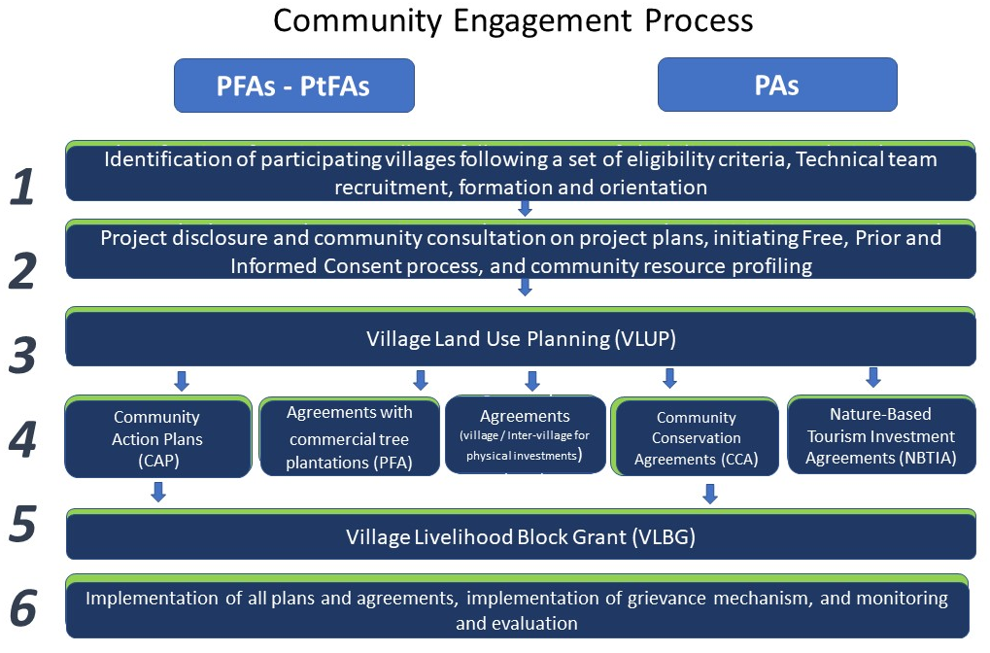
The community consent or agreement consists in three main components
- A consent or agreement signed and stamped by the village authorities and signed by each head of households
- An attendance list to record participation and displaying gender and ethnic indicators
- A record of participants concerns, questions and feedback, commonly known as the minutes of consultation which has resulted in FPIC

Field team formation
Very early in the project period district authorities will be requested to identify line agency staff to become members of the district field teams. The head of District Coordination Unit, together with the project hired Project Assistants, will provide oversight and guidance to ensure good coordination and synchronized implementation of forestry management, conservation and ecotourism activities.
- Criterions for team member selection: Gender balance. District Livelihood Development and Forestry teams should each include at least one woman. This measure will ensure that gender balance is respected. The proportion of women in the teams will be informed by the NCAW requirements for women participation at each level.
- Ethnic composition. A staff inventory for the teams will be compiled. Criterion for working with the project includes the ability to speak the ethnic language found in each project area to ensure that the team members can communicate linguistically, culturally and in a gender-sensitive manner with the target communities.
Remark: In the case there are no staff members from the relevant ethnicity available within the DAFO, LWU or the LFNC team members, then the project will take into consideration involving ethnic staff from Committee for Advancement of women (CAW) based at district level or hire interpreters from district or village level to ensure that the interface occurs in the relevant ethnic language(s).
- Commitment. The project will ensure that individuals nominated to fill key positions are committed to collaborate with the project for the length of the project in order to avoid turn over and loss of trained staff during implementation.

Implementation approach

Village typology
Villages are the basic unit of community engagement processes. The ethnic composition of each community will have a huge impact on the time needed to conduct project activities and the working approach, duration needed, budget and team composition.
The LLL project includes villages from various ethnic groups and with varying livelihood styles. Each ethnic group is distinctive in ways that are sometimes readily apparent and at other times not open to direct observation. One of the most important aspects of that distinctiveness is the way in which each group conceptualizes notions such as territories and forests, and their presuppositions, assumptions, and associations, or beliefs about the world, resulting in local ecological knowledge that has survival value for the group as a whole. Each group also has its own definitions of gender roles, and uses and knowledge of the forest will differ by gender. Other elements of social diversity need to be considered as well, to ensure that the project is socially inclusive and socially sustainable.

Once the project has determined the eligibility of the target villages, the next step consists in conducting an inventory of ethnicity in each of the target area in order to come up with a typology of villages. In order to collect the relevant information, the project will collaborate with the LFND from each district and province targeted by the project.
The success of the LLL project depends upon the ability of the project to comprehend and learn from the people residing in the PFAs as well as the ability to communicate new ideas and concepts to villagers in ways that are meaningful and that will allow them to improve their livelihoods and well-being.

The LLL Project distinguishes 3 categories of village for project planning and implementation:
- Category 1: Lao-Tai villages. In this case the team will be able to directly implement the work without any translation from Lao; attention will be devoted to include women in project activities and to ensure participation of all vulnerable groups.
- Category 2: homogenous ethnic villages. The challenges include providing an interface in the non-Lao ethnic language, and to involve customary leaders.
- Category 3: mixed villages (including Lao-Tai); Ethnically mixed villages will be the most difficult case. The team will need to ensure the participation of each ethnic group during field activities. Time should be allowed to hold separate meetings with each ethnic group to ensure that the technical visits are not dominated by one ethnic group. Facilitation must be conducted in many languages and special attention should be devoted to include all customary authorities and women. In case that none of the staff can speak the language, the project must recruit one (or more) language facilitators at village level. The team will also ensure the participation of all vulnerable groups.

Village categories
 | Category 1 | Category 2 | Category 3
Ethnic  composition | Lao-Tai villages | Homogenous village  (Mon-Khmer,  Sino-Tibetan or  Hmong-Iu-Mien villages | Mixed villages  (consolidated,  multi-ethnic)
Issues | Gender issue  Vulnerable | Gender issue  Vulnerable  Ethnic language | Gender issues  Vulnerable  Multiple Ethnic languages

Community Engagement
CE relates to communication, translating, listening and paying attention to representatives of all social groups in the community, concerning their traditional forest use and classification of the ethnic groups, recognizing their livelihood strategies as part of forest management planning, paying respect to the groups’ indigenous knowledge, and ensuring they benefit from the project and no harm is caused. Secondly, it is about ensuring that Ethnic Group(s), women and vulnerable groups are given space to participate. This project’s CE implementation approach consists in:
- Training of provincial counterpart and district teams on Community Engagement Guidelines and ESF throughout the project life; this training includes raising awareness of ethnic, vulnerability and gender issues.
- Facilitation in technical work. The facilitation of village consultation processes will make sure that the village is informed prior to the visit, that the invitation specifically asks women to participate, that village meetings allow for translation into ethnic languages, , that vulnerable groups are included, that focus group discussions in smaller groups are conducted and that women will make up special focus groups and have translation provided.
- Integrating ethnic group, vulnerable groups and gender issues into the regular technical training that is carried out in LLL Project. Thus, ethnic group issues and gender issues need to be integrated with technical training and technical guidelines to allow for better communication and participation in project activities.

Protocol for community engagement
The protocol for community engagement consists in 10 principles that are to be applied both to district teams when going to the work at field level in both PAs and PFAs/PtFAs. It is divided into four phases: (1) organization phase, (2) preparation appointing and coordinating phase; (3) participatory facilitation phase; and (4) recording phase.
Monitoring and evaluation arrangements
In order to address any potential project risks, and also to give participating villagers opportunities to suggest any measures that may enhance project benefits and further strengthen sustainability of affected people’s livelihood, the project will carry out Participatory Monitoring and Evaluation (PM&E) to allow villagers to voice concerns they may have or the hardships they may be experiencing. A village wide meeting will be held on a quarterly basis where villagers discuss concerns and grievances, as well as measures to enhance project benefits.
The LNFD and the LWU, established at each of the three levels will be involved in monitoring ESF compliance altogether with the District and provincial ESF Focal Point. It is their role to ensure that policy guidance on ethnic and gender inclusion is provided in a timely manner to the participating institutions in the performance of their roles and functions. The district ESF focal points will be in charge of monitoring ESF compliance and to prepare summary on ESF performance/ issues for the district, submit to DPT management on a quarterly basis.

Resettlement Policy Framework (RPF)

It is unlikely that the activities supported during the project will have significant or irreversible impact would occur under the project. Furthermore, physical relocation of households or businesses is not allowed. Although minor impacts are expected the impact will be minimized, mitigated and compensated with management incorporated at the management stage. Activities to support livelihood development will unlikely result in any adverse environmental impacts.

The Resettlement Policy Framework (RPF) set out policies and procedures to be applied when such land has to be acquired, so that the project complies with existing regulations of Lao PDR, PM Decree 84, and the ESS5. In other words, the policies and procedures provided under this RPF will apply when the project requires the involuntary taking of land resulting in: (i) relocation or loss of shelter; (ii) loss of assets or access to assets; or (iii) loss of income sources or means of livelihood, whether or not the affected persons must move to another location. Those impacts due to the involuntary restriction of access to areas resulting in adverse impacts on the livelihoods of the displaced persons are addressed in the main body of this CEF.

Land or assets acquisition
Under the project, all efforts will be made to avoid, or minimize if unavoidable, involuntary resettlement. No land acquisition is expected because any civil works will be constructed on public un-encroached state land.
In case of voluntary acquisition of land or other assets (including restrictions on asset use) caused by sub-project implementation either through contribution or with compensation by communities, the project will follow the FRALA principle developed under the LLL project. The “Framework for Resettlement and Acquisition of Land and Assets” establishes principles and procedures to be followed to ensure equitable treatment for, and rehabilitation of, any person adversely affected by sub-project implementation and allows for acquiring assets through the following two methods:
Voluntary Contributions: users (the size of land contributed on a voluntary basis should not exceed 10% of that individual’s total land holding). Almost all impacts under the PRF III are expected to be addressed through voluntary donations
Compensation at replacement cost: If in a highly unlikely event that any of the conditions for voluntary contributions cannot be met, the impact is considered as involuntary and will be addressed through compensation at replacement value.

Grievance Redress Mechanism

In compliance with the World Bank’s ESS10 requirement, a specific grievance mechanism will be set-up for the project. In Laos there are four possible paths that citizens can follow to seek redress of any grievance with Lao State institutions, including: 1) administrative (ທາງບໍລິຫານ), 2) judicial (ທາງຕຸລາການ), 3) legislative (ທາງນິຕິບັນຍັດ) and 4) Party internal audit and mass organizations. The the LLL project will use a fifth path for grievances related to the project or sub-projects. All the details of the GRM including guiding principles, process from village to central level, the 7 steps processes, all templates to be used are provided in the CEF and have also been explained in the SEP.

LLL Grievance Redress Mechanism
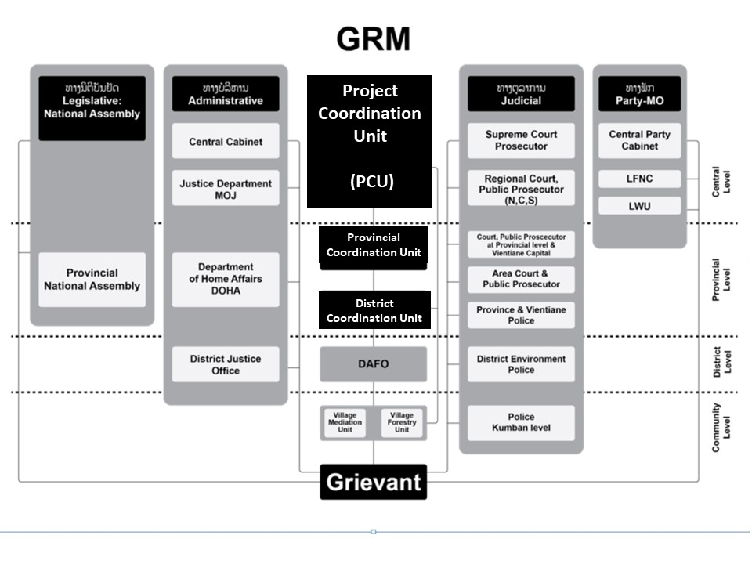
Steps process to redress grievances
